Adsorption behaviors of copper (II) and lead (II) ions by crosslinked starch graft copolymer with aminoethyl group
Deng Kuilin, Jia Na, Zhang Yaqin, Yan Dawei, Hou Duanmin
(College of Chemistry and Environmental Science, Hebei University, Baoding, 071002)
Abstract An investigation was undertaken regarding the adsorption behaviors of copper (II) and lead (II) ions from aqueous solutions by crosslinked starch graft copolymers with aminoethyl groups, which were synthesized by grafting 2-aminoethyl methacrylate onto crosslinked starch. The dynamic adsorption method was utilized to evaluate adsorbability of graft copolymer under various parameters such as metal ion concentration, adsorption time, grafting percentage and adsorption temperature. The adsorption time reaching equilibrium for Cu (II) and Pb (II) was found to be two hours and one hour, respectively. The adsorption capacity increases with the increasing graft percentage and metal ions concentration. For the starch graft copolymer with grafting percentage of 75.5%, when the metal ions concentration was about 5.0 mmol/L, the saturation adsorption capacity of Cu (II) and Pb (II) are 21.05 mg/g and 144.08 mg/g (dry weight), respectively, and its desorption percentage is about 95%.
Keywords : Adsorption; Heavy metal ions; Starch graft copolymer; Wastewater treatment
1 INTRODUCTION
Many efforts have been focused on the removal of some heavy metal ions such as Pb (II), Cu (II), Hg (II), Ag (I) and Cr (VI) from industrial effluents, mine water and water supplies due to their toxicity to human and natural wildlife in recent years ^{[1-5]}. It is well known that heavy metal ions released into the environment are highly toxic to the living organisms and change ecological balance by environmental cycling ^{[6]}. Consequently, various methods including reverse osmosis, ion-exchange, adsorption and electrodialysis techniques have been developed in order to remove or recover the heavy metal ions from all kinds of waste water ^{[7-8]}. Among the various separation and pre-concentration techniques, adsorption of heavy metal ions on many water-insoluble stationary phases has been widely investigated. Some functionalized polymers, silica and activated carbon with chelating groups have become the most favored adsorbents due to their good mechanical strength, large surface, fast adsorption, inexpensiveness and availability ^{[9-10]}. Recently, the adsorbents based on natural products and their derivatives deserved particular attentions because of an increasing interest in the removal of heavy metal ions from waste water. For example, crosslinked amphoteric starch with quaternary ammonium groups can effectively remove Cr (VI), Cu (II) and Pb (II) ions in aqueous solution ^{[11-13]}. Zhang et al reported the adsorption behaviors of Cu (II) onto water-insoluble phosphate carbamate and its maximum adsorption capacity was 1.60mmol/g ^{[14]}. Also, chitin, its derivatives ^{[15]} and modified cellulose ^{[16]} have been studied with respect to their ability to remove heavy metals from aqueous solution.
Starch is one of important agricultural biopolymers used in the industry due to its low cost, renewability and biodegradability. However, starch by itself can not be directly applied in adsorbing heavy metal ions because it has inherently no chelating or complexing abilities. Therefore, it is very necessary that functional groups are introduced into the starch backbone by grafting method to obtain the effective adsorbents for heavy metal ions. Dong et al reported the adsorption behaviors of Cu(II) onto cornstarch copolymer with dimethylaminoethyl methacrylate and gave the optimal adsorption condition ^{[17]}.
In this study, the newly-synthesized starch graft copolymers containing aminoethyl groups was used for removing Cu (II) and Pb (II) ions in the aqueous solution by the effective complexation of amine group with Cu (II) and Pb (II) ions. The effects of various parameters such as metal ions concentration, adsorption time, adsorption temperature and grafting percentage of the starch graft copolymers were investigated. Moreover, the adsorbed Cu (II) and Pb (II) ions can be easily desorbed by treating with HCl solution and the desorption percentage reached above 95% when desorbing with 1 N HCl solution for 1 h at room temperature.
2. EXPERIMENTAL PART
2.1 Materials
Commercial crosslinked starch powder, from Guangxi Starch Factory in China, was dried at 105ºC before use. 2-aminoethyl methacrylate hydrochloride (AEMH) was purchased from Acros, 99%. All solutions of copper (II) sulfate and plumbum acetic were prepared using deionized water. The other reagents and solvents were commercially available and were used without further purification.
2. 2 Synthesis of starch graft copolymer
Four starch graft copolymers with different grafting percentages (GP) (27.5%, 50.0%, 75.5% and 100.3%), used as the absorbents for Cu (II) and Pb (II) ions in this work, were prepared by varying the monomer concentration. In a typical graft copolymerization, 2 g of crosslinked starch and 50 mL deionized water were added into a 100 mL three-neck flask equipped with a stirrer and immersed in a thermostat water bath. The N₂ gas was purged into the flask to remove the oxygen during the reaction. The required amount of AEMH was added into the flask at 45ºC in order to keep acidic reaction system. Then, a conventional grafting initiator for starch, Ce⁺⁴ ion (2.0×10⁻³ mol/L) was injected into the flask with syringe to initiate the graft copolymerization of AEMH onto starch. After a given time, the stoichiometric NaOH aqueous solution was added into the flask in order to convert AEMH into 2-aminoethyl methacrylate moiety. Then the reaction mixture was added to cool water to remove the unreacted monomer and the possibly formed homopolymer of 2-aminoethyl methacrylate. The crude graft starch copolymer was filtered and extracted by Soxhlet extraction with acetone for 24h. The final starch graft copolymer was then dried to a constant weight under vacuum at 60ºC for 24 h, weighed and calculated the grafting percentage. The grafting percentage was calculated according to the following equation:
Grafting percentage % (GP) = (Polymer in graft/Weight of substrate) × 100
2. 3 Adsorption procedure
The adsorption experiments were carried out in a series of flasks containing the desired dose of the grinded starch graft copolymer and 20 mL Cu (II) or Pb (II) solution at the desired concentration in a constant temperature bath. After stirring for a fixed adsorption time, the adsorbents were separated from the adsorption media and the concentration of Cu (II) or Pb (II) ions after adsorption was determined by the chemical titrimetric analysis. The adsorption capacity was calculated from the following equation:
Q = (C₀-C₁) V﹡M / m
where Q is the adsorption capacity of starch graft copolymer (mg/g); C₀ and C₁ (mol/L) are the initial and final concentrations of Cu (II) and Pb (II) in the adsorption medium, respectively, V (mL) and m (g) are the volume of Cu (II) solution and the amount of the starch graft copolymer, respectively, and M is the molecular weight of Cu (II) or Pb (II).
3 RESULTS AND DISCUSSION
3.1 Structure-conforming of starch graft copolymer
As shown in Fig. 1, the grafting copolymer was conformed by comparing the IR spectrum of pure starch with its graft copolymer. The main difference observed is the appearance of an absorption band at 1732 cm⁻¹ which is ascribed to the carbonyl group of 2-aminoethyl methacrylate in the IR spectrum of starch graft copolymer. Also, the characteristic absorption at 1575 cm⁻¹ can be attributed to the deforming absorption of N-H bond, which were not observed in the IR spectrum of the pure starch. The above-mentioned results clearly indicated that the monomers 2-aminoethyl methacrylate have been successfully grafted onto the macromolecular chains of starch.
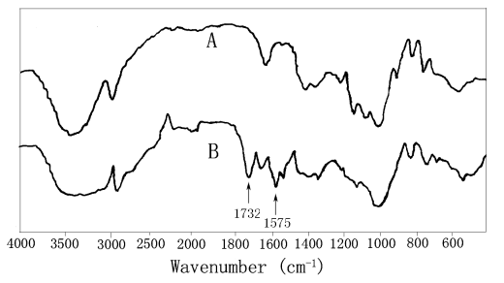
Fig.1 IR spectra of pure starch (A) and starch graft copolymer (B)
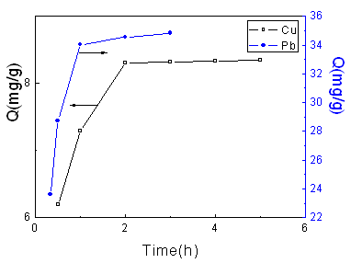
Fig.2 Effect of adsorption time on adsorption capacity
Temperature: 25 ℃; [Cu(II)]: 1.2475 mmol/L; GP: 75.5 %.
Temperature: 25 ℃; [Pb(II)]: 1.2503 mmol/L; GP: 75.5 %.
3.2 Effect of adsorption time
As shown in Fig.2, the adsorption capacity of Cu (II) and Pb (II) increases with the adsorption time during the first 2 h and 1 h, respectively, and then level off toward the equilibrium adsorption capacity. It can be ascribed to the following facts that the adsorption process is a heterogeneous reaction, and the complexation between Cu (II), Pb (II) and aminoethyl required a definite time to get the adsorption equilibrium. Compared with Cu (II) ion, the adsorption of Pb (II) ion onto starch copolymer reaches dynamic equilibrium in a shorter time, which is consistent with the reports by Sun et al ^{[18]}.
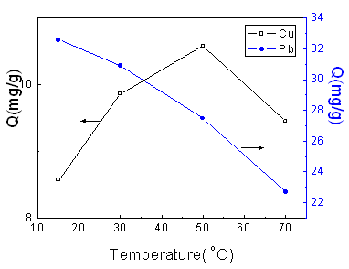
Fig.3 Effect of temperature on adsorption capacity
[Cu (II)]: 1.2475 mmol/L; GP: 75.5 %; Adsorption time: 2 h.
[Pb (II)]: 1.2503 mmol/L; GP: 75.5 %; Adsorption time: 1 h.
3.3 Effect of adsorption temperature
Fig.3 shows the effect of the adsorption temperature on the adsorption capacities toward Cu (II) and Pb (II) ions from aqueous solution. For Cu (II), when the temperature is lower than 50ºC, the solubility of the poly(aminoethyl methacrylate) on the surface of adsorbent is enhanced with the increasing of the temperature, so the content of amino group which can complex with Cu (II) ion increases stepwise; when the temperature is higher than 50ºC, the desorbing plays an important role, so there is a maximum at 50ºC. The adsorption capacity of Pb (II), however, drops down all the time with the temperature increasing from 15ºC to 70ºC. It can be well described by the work of Zhou et al that the adsorption of Pb (II) is an exothermic process, so low temperature is propitious to adsorption ^{[19]}.
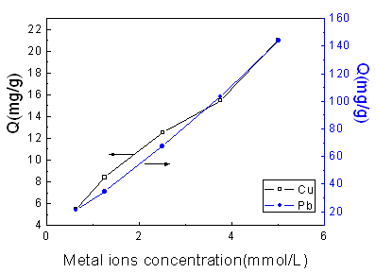
Fig.4 Effect of metal ions concentration on adsorption capacity
Cu: GP: 75.5 %; Adsorption time: 2 h; Temperature: 25ºC.
Pb: GP: 75.5 %; Adsorption time: 1 h; Temperature: 25ºC
3.4 Effect of metal ion concentration
As shown in Fig.4, adsorption capacity of starch copolymer towards Cu (II) and Pb (II) is highly concentration-dependent. When the metal ions concentration increased, the adsorption capacity is increased apparently. In fact, the opportunity of collision between metal ions and amino groups increased with the enhancing of the metal ions concentration under the same condition, which consequentially leads to the higher adsorption capacity of the adsorbent. Considering the actual waste water, it is necessary to announce that lower concentration of metal ions was employed in this work.
3.5 Effect of grafting percentage
Fig. 5 presents the effect of the grafting percentage of the starch graft copolymers on the adsorption capacities toward Cu (II) and Pb (II) ions from aqueous solutions. As expected, higher grafting percentage results in higher adsorption capacity. Apparently, the more amine groups were attached to the surface of the starch graft copolymer with higher grafting percentage, which affirmatively increase the adsorption ability toward Cu (II) and Pb (II) ions by the stronger complexation reaction.
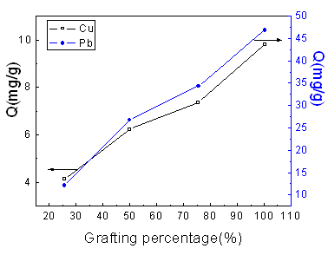
Fig.5 Effect of grafting percentage on adsorption capacity
Adsorption time: 2 h; Temperature: 25ºC; [Cu (II)]: 1.2475 mmol/L.
Adsorption time: 1 h; Temperature: 25 ºC; [Pb (II)]: 1.2503 mmol/L.
3.6 Blank adsorption experiment of starch and desorption study
In comparison with the grafting starch copolymer, crosslinked starch by itself was also used to adsorbed Cu (II) and Pb (II) ions at the same conditions. The adsorption capacity of Cu (II) and Pb (II) onto pure starch is as low as 0.34 and 2.55 mg/g, respectively, indicating that the introduction of 2-aminoethyl methacrylate onto starch is very essential for its effective adsorption behaviors.
The desorption efficiency, as an important characteristic of adsorbents, was evaluated by desorption agents 1 N HCl at 25ºC over 1 h. The desorption percentages of different grafting percentage including 27.5%, 50.0%, 75.5% and 100.3% are 94%, 96%, 95% and 96%, respectively. The metal ions are consequentially released from the graft starch copolymer due to the more affinity of HCl with the amino groups, when the acidic solution makes contact with the loaded adsorbent. Moreover, most of the amino groups are located on the particle surface, leading to the fast and complete desorption process.
3 CONCLUSIONS
Crosslinked starch graft copolymers with aminoethyl groups were prepared by grafting of 2-aminoethyl methacrylate onto crosslinked starch. Their adsorption behaviors of the starch graft copolymer toward copper (II) and lead (II) ions from aqueous solutions were evaluated by a batch technique under various conditions. For the starch graft copolymer with the grafting percentage of 75.5%, the saturation adsorption capacity toward copper (II) and lead (II) ions was found to be 21.05 and 144.08 mg/g, respectively. Besides, the metal ions concentration and grafting percentage have considerable influences on the adsorption of copper (II) and lead (II) ions on the starch graft copolymer.
References
[1] Xu S M, Zhang S F, Lu R W et al. J. Applied Polymer Sci., 2003, 89: 263.
[2] Xu S M, Feng S, Yue F et al. J. Applied Polymer Sci., 2004, 92: 728.
[3] Xu S M, Feng S, Peng G et al. Carbohydrate Polymers, 2005, 60: 301.
[4] Huang M R, Li X G, Peng Q Y. Gongye Shui Chuli, 2005, 25 (1): 13.
[5] Huang M R, Li X G, Li S X. Huaxue Jinzhan, 2005, 17 (2): 299.
[6] Terashima Y, Ozaki H, Sekiue M. Wat.Res, 1986, 20: 537.
[7] Boto B A, Pawlowski L. Water Treatment by Ion Exchange, Chapman and Hall, New York, 1987.
[8] Barcicki J, Pawlowski L, Cichocki A, in: L. Pawlowski (Ed.), Physicochemical Methods for Water and Wastewater Treatment, Pergamon, London, 1980.
[9] Liu M H, Zhang X S, Deng Y. Shui Chuli Jishu, 2000, 26 (4): 222.
[10] Sun X Z, Su Z X.. Huaxue Yanjiu, 2005, 16 (1): 29.
[11] Lu W, Yang J Z, Cui C X. J. Appl. Polym. Sci., 2003, 89: 263.
[12] Xu S M, Feng S , Yue F, et al. J. Appl. Polym. Sci., 2004, 92: 728.
[13] Xu S M, Feng S, Peng G, et al. Carbohyd. Polym., 2005, 60: 301.
[14] Guo L, Zhang S F, Ju B Z, et al. Carbohydrate Polymers, 2006, 63: 487.
[15] Yang Y, Shao J. J. Appl. Polym. Sci., 2000, 77: 151.
[16] Padilha P M, Pacha J C, Moreira J C, et al. Talanta, 1997, 45: 317.
[17] Dong Y M, Lu J M, Bao Z Y. Haerbin Gongye Daxue Xuebao, 2004, 36(9): 1161.
[18] Sun J M, Xu P, Sun H W. Fenxi Huaxue, 2004, 32(10): 1356.
[19] Zhou S Y, Wang J, Chen G L. Fujian Huagong, 2002, 1: 4.

