Quality :
Index | TCCA | DCCNA
effective chlorine:
theoretical value | 91.5 | 64.5
excellent grade | 90 | 60
first grade | 87 | 60
qualified grade | 85 | 55
appearance | white powder | white powder
water (%) | <0.5 | <0.5
PH value | 2.7～3.3 | 5.8～7.0
speed of dissolving in water | slowly | quickly

Process route:
TCCA obtained by the continuous synthesis
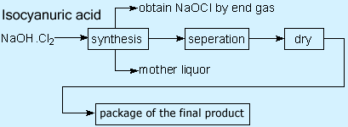
mother liquor goes to the system of 3-wasce treatment.
DCCNa obtained by the double decomposition synthesis
TCCA.CA
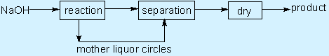

Consumption of main raw materials & power :
Name | Specification | Unit | TCCA | DCCNa
CA | >98% | t/t | 0.76 | 0.78
Chlorine | 96 or 99% | t/t | 20 | 1.3
NOH | ～30% | t/t | 3.5 | 2.8
Water |  | t/t | 10 | 5
Electricity | 380V | KWH/t | 200 | 100
Steam | 0.7MPa | t/h | 3 | 6
Freezing | -10°C | KW | 465 | 200
(1) In order to reduce the cost of production ,suggest to use 96% crude chlorine .
(20 The consumption of Naocl is included also .
Environmental protection :
The process route of three-waste treatment
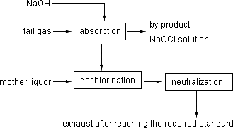
There's no three-waste to discharge in production of DCCNa.

